Pension Annuitant Dataset Generation
This approach generates a 20,000‐record synthetic pension annuitant dataset with the specified fields. We base key distributions on PBGC Data Tables and Form 5500 trends pbgc.govpbgc.gov. In particular, PBGC data show that most retired payees are aged 65–79 (over 60% of retirees) with an average monthly benefit around $585 pbgc.govpbgc.gov. We use these trends to shape age, gender, and benefit distributions (e.g. ~60% male) and enforce logical consistency (retirees older than deferred, benefit start ≥ retirement year, premium/reserve positively correlated with benefit, etc.).
- pbgc.govpbgc.govpbgc.gov Age and Gender – PBGC reports ~41.8% of retirees are 65–74 and ~45.2% are 75–84 pbgc.gov, with about 60–63% male pbgc.gov. We simulate retirees’ ages roughly Normal(~75, sd~8, min65) and deferred participants younger (mean~55), with ~60% male overall.
- govinfo.gov Annuity Type (Retiree vs Deferred) – By definition a “deferred annuitant” is vested but not yet receiving benefits govinfo.gov. We assign ~60% of records as retirees and ~40% as deferred, ensuring retirees’ ages ≳65 and deferred ≲64.
- pbgc.gov Plan Type and Benefit Form – We include common payout forms: Single Life, Life 10-Year Certain, and Joint 50% Survivor. PBGC’s guidance notes straight-life and joint-50% as the two most common annuities pbgc.gov. We randomly assign these (e.g. 50% single, 20% 10-year, 30% joint) and draw a base monthly benefit from a lognormal distribution centered near the PBGC average (~$500–600). We then adjust it by form: e.g. joint-50% annuities pay ~20% less than equivalent single-life benefits.
- soa.orgasppa-net.org Risk Drivers (Longevity/Health/Region/Occupation) – To capture socio‐economic mortality differences, we assign each individual a Longevity Group (1–5) and Health Group (1–3) at random. We also simulate a 9-digit ZIP+4 code. Actuarial studies show life expectancy varies by region/ZIP and occupation soa.orgasppa-net.org, so we include an Occupation Class (White vs Blue Collar) with ~60% white-collar, reflecting that white-collar participants live longer on average asppa-net.org. (An environmental/region score is also randomly generated for further analysis.)
- dol.gov Premium and Reserve Calculations – We compute a “Premium” that grows with benefit size and decreases with age (younger beneficiaries cost more). For example, we multiply benefit by an age-based factor (higher for younger ages) and add a small loading for joint or 10-year forms. The Reserve is the approximate present value of remaining payments, using a 3% discount and typical life expectancy (≈15–17 years at age 65 dol.gov). This makes reserve and premium positively correlated with benefit and sensitive to age/plan form.
~Chigarire, Luckson
Data generation code in R:
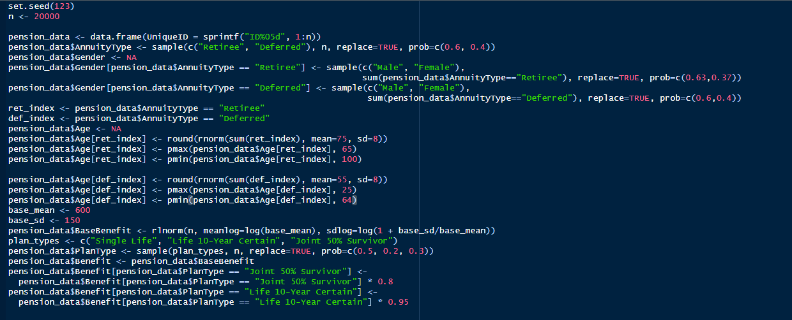
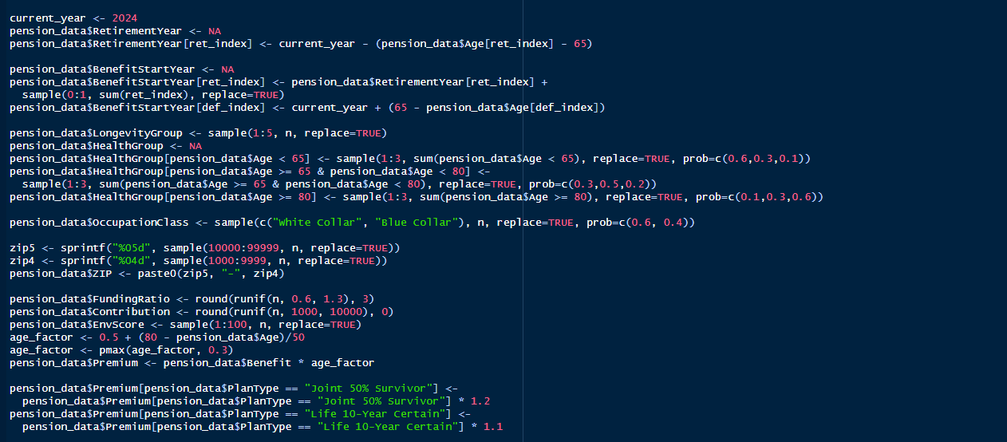


Dataset Created
